Send an announcement to a channel
Sometimes your message needs to stand out. With options for a headline and image, channel announcements help your message cut through noise.

Create an announcement
- In the channel, select Format under the box where you type your message.
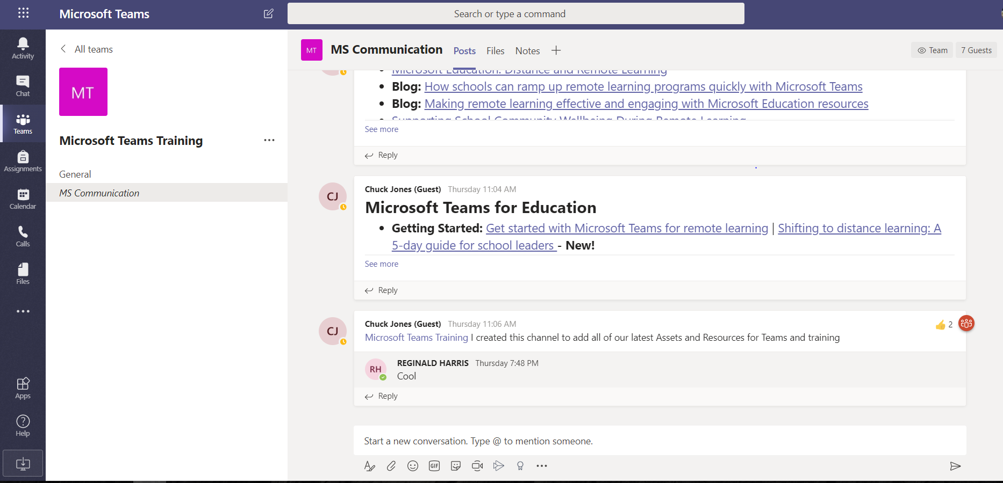
- At the top of box that appears, click the arrow next to New conversation > Announcement.
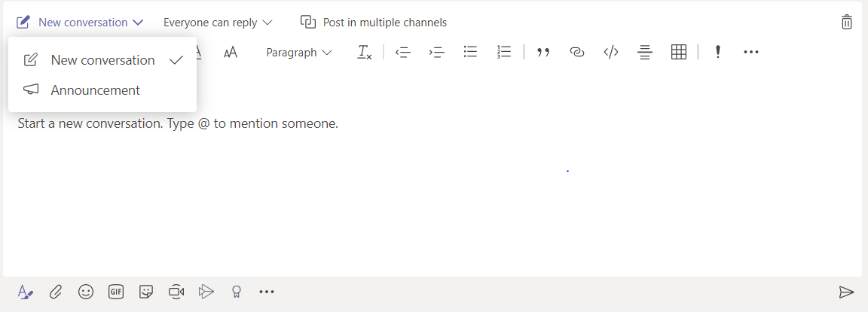
- Type a headline, change its background color, or add a background image for the headline area—lots of options!
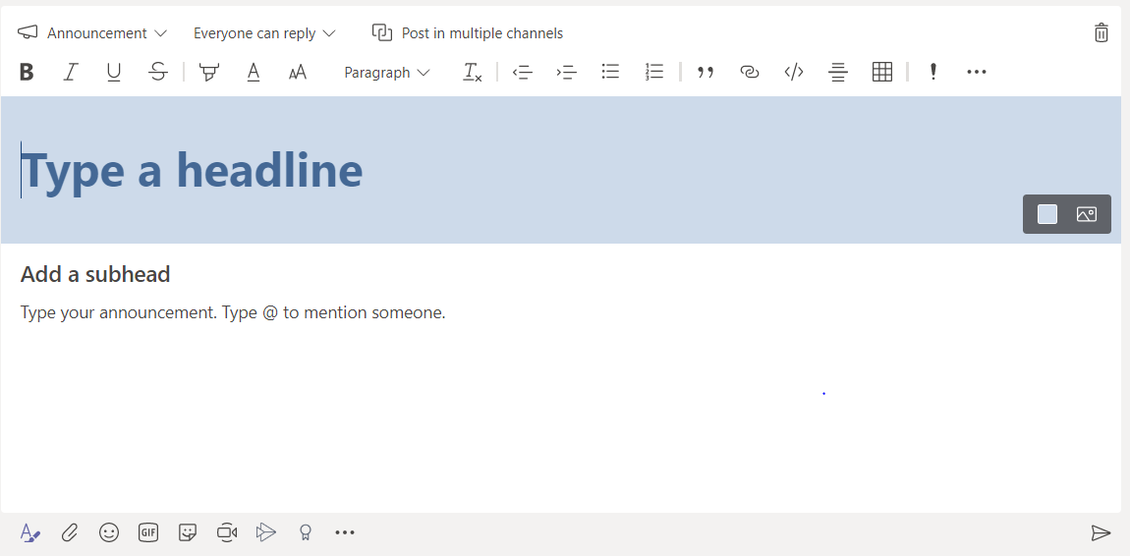
Send button
Type announcement here
- Type the topic of your announcement in the Add a subhead area, then the body of your message, and select Send .
